The Effect of Frailty on Early Postoperative Outcomes of Lobectomy for Lung Cancer in Older Adults – A United States National Retrospective Cohort Study

Contributors:
Diana Barragan-Bradford, MD¹
Ruben Oganesyan, MD²
Alexander Nagrebetsky, MD, MS¹
Omar Hyder, MD, MS¹

From the (1) Massachusetts General Hospital, Department of Anesthesiology, Division of Critical Care Medicine, Boston, MA; (2) Beth Israel Deaconess Medical Center, Department of Pathology, Boston, MA

Corresponding Author:
Omar Hyder, MD, MS
Department of Anesthesia, Massachusetts General Hospital
55 Fruit Street, Boston, MA 02114
Email: ohyder@mgh.harvard.edu

Key Words: Frailty, lung cancer, lobectomy, failure-to-rescue

Running Title: Frailty and pulmonary lobectomy.

ABSTRACT
Introduction: Pulmonary lobectomy represents the primary curative treatment for lung cancer in older adults, yet frailty's impact on critical early postoperative outcomes remains inadequately characterized. This analysis examined the effect of preoperative frailty on early postoperative mortality and failure-to-rescue in a contemporary national cohort.
Materials and Methods: This retrospective cohort study analyzed older adults undergoing pulmonary lobectomy for lung cancer using the National Inpatient Sample (2016-2022). The Johns Hopkins Adjusted Clinical Groups (ACG) frailty indicator and Hospital Frailty Risk Score (HFRS) were used to identify frail patients. Multivariable logistic regression examined associations between frailty and failure-to-rescue (death after postoperative complications) and 14-day in-hospital mortality.
Results: Among 110,460 patients aged ≥65 years, frailty prevalence was 5.7% (n=6,290) by ACG indicator and 19.8% (n=21,915) by HFRS (≥5). Among ACG-defined frail patients, the most common frailty-defining conditions were dementia (37.8% of frail patients), malnutrition (36.0%), and weight loss (11.6%). Overall complication rate was 39.3%, but frail patients (HFRS ≥5) experienced higher rates (69.0% versus 32.0%), higher hospitalization costs (median $104,446 versus $88,532), and reduced likelihood of home discharge (83.3% versus 95.5%; all p<0.001). Overall 14-day mortality was 0.8%. Frail patients had higher rates of failure-to-rescue (ACG: 3.7% versus 1.7%; HFRS: 4.1% versus 0.8%) and mortality (ACG: 2.1% versus 0.7%; HFRS: 2.8% versus 0.3%; all p<0.001) compared with non-frail patients. After multivariable adjustment, frailty remained associated with failure-to-rescue (ACG: OR 2.01, 95% CI 1.36-3.06; HFRS: OR 4.66, 95% CI 3.27-6.63) and 14-day mortality (ACG: OR 2.70, 95% CI 1.77-4.10; HFRS: OR 9.30, 95% CI 6.52-13.26). Frailty accounted for 68% of early deaths within the frail cohort and 11% of all cohort deaths.
Discussion: Preoperative frailty was associated with early postoperative mortality and failure-to-rescue rates following pulmonary lobectomy in older adults, emphasizing the need for systematic frailty assessment, enhanced perioperative surveillance, and targeted interventions for this population.

INTRODUCTION
Frailty is known to influence outcomes in older patients with cancer, yet its specific impact on surgical outcomes following pulmonary lobectomy remains inadequately characterized. As the population ages and lung cancer treatment increasingly shifts toward older adults, understanding how frailty–characterized by reduced physiologic reserve and heightened vulnerability to surgical stressors–influences postoperative outcomes has become critical for surgical decision-making and patient counseling.
Pulmonary lobectomy represents the primary curative treatment for lung cancer and is the most common thoracic surgical procedure in the United States (US). While advances in surgical technique and perioperative care have improved overall outcomes, older adults experience disproportionately higher complication rates compared to younger cohorts, including postoperative atrial arrhythmias (occurring in more than 20% of patients over age 70 compared to less than 10% of those under 60), long-term pain, dyspnea, and worse physical functioning.(1-6) Although severely frail patients are typically excluded during preoperative evaluation, a subset of frail individuals still undergoes lobectomy, creating a clinically relevant population for study.(7)
Current evidence examining frailty's impact on lobectomy outcomes in older adults is limited by small sample sizes, heterogeneous populations, and methodological constraints. Most studies rely on outdated data or focus on high-risk procedures rather than the routine lobectomies that constitute the majority of thoracic oncology practice.(7, 8) Furthermore, most studies have focused on complication incidence rather than rescue from complications once they occur. Importantly, existing research has not adequately examined failure-to-rescue—death following a surgical complication—which represents a potentially modifiable outcome through enhanced perioperative surveillance and intervention. For geriatric oncology providers, understanding both the incidence of complications and the ability to effectively manage them is essential for optimizing patient care.
To address these knowledge gaps, this analysis investigates the relationship between frailty and early postoperative outcomes, including failure-to-rescue and mortality—using two complementary frailty classification systems in a large, contemporary national cohort of older adults undergoing pulmonary lobectomy for lung cancer.

MATERIALS AND METHODS
Data Source
The Healthcare Cost and Utilization Project’s National Inpatient Sample (HCUP-NIS) database from 2016 to 2022 were utilized for this study. HCUP-NIS is a 20% stratified sample of inpatient hospital discharges, drawn from a sampling frame that covers more than 97% of the US population.(9) This de-identified, publicly available dataset includes patient records with demographic information, diagnostic and procedure codes, timing of procedures, length of stay, discharge disposition, mortality, total charges for inpatient stay, and hospital characteristics - data typically captured in hospital discharge abstracts. The NIS enables weighted national estimates of healthcare utilization and outcomes. This retrospective cohort study was deemed exempt from review by the MassGeneral Brigham Institutional Review Board on 7/22/2025.

Patient Selection
All hospitalizations listing an ICD-10-PCS code consistent with pulmonary lobectomy(10, 11) were identified. Records of older adult patients (aged ≥65 years) with a diagnosis of lung cancer (ICD-10-CM C34.0) who underwent pulmonary lobectomy on the first day of an elective hospital admission were selected for analysis. Records missing data on sex or death (<0.05%) were excluded after confirming a missing completely at random (MCAR) pattern (Little’s test p=0.328).(12) The study was conducted and reported in accordance with STROBE recommendations (supplemental online content).(13)

Definition of Frailty
Two complementary classification systems were used to define frailty. The Johns Hopkins Adjusted Clinical Groups (ACG) Frailty Defining Indicator served as the primary binary measure (frail/non-frail) because it provides component-level data allowing identification of specific frailty domains driving outcomes.(14, 15) The Hospital Frailty Risk Score (HFRS) served as a complementary continuous measure to examine dose-response relationships. For binary comparisons parallel to ACG classification, patients with HFRS ≥5 (intermediate or high frailty risk) were classified as frail.(16)
To minimize misclassification from iatrogenic conditions and ensure frailty diagnoses reflected preoperative rather than postoperative status, only patients with length of stay ≤14 days were included. This cutoff was selected based on evidence demonstrating low likelihood of developing moderate-to-severe hospital-acquired malnutrition within this timeframe, thereby reducing the risk of reverse causation, in which postoperative complications drive frailty classification rather than frailty predisposing to complications.(17-19)

Complications and Organ-system Dysfunction
A data-driven approach was used to define potentially fatal complications, given the absence of standardized classifications in administrative data. All ICD-10-CM codes from patients who died in-hospital were tabulated and manually reviewed. Codes representing postoperative complications or organ dysfunction consistent with Clavien-Dindo Surgical Complication Classification Grade II or higher were retained.(20) This list served as the operational definition for identifying potentially fatal complications in the full cohort, ensuring clinical relevance over reliance on generic code lists. For example, when patient records listed both diagnoses of atelectasis and pneumonia, only pneumonia was retained as the more clinically significant complication directly linked to mortality risk. Similarly, acute respiratory failure was included while chronic respiratory conditions were excluded. One or more relevant complications or organ-system dysfunction were present in 99.4% (840 of the 845) patients who died.

Failure-to-Rescue
Failure-to-rescue was defined as in-hospital death after a potentially fatal complication or organ-system dysfunction.

End Points
The primary endpoint was failure-to-rescue resulting in in-hospital mortality. The secondary end point was overall in-hospital mortality in the cohort regardless of complication status.

Covariates
Patients with a Charlson Comorbidity Index ≥3 were classified as having a higher comorbidity burden.(21, 22) ICD-10-PCS codes were used to define laterality and location of the resected lobe(s). Codes describing percutaneous endoscopic access were used to identify minimally invasive surgical (MIS) procedures, including video-assisted thoracoscopic surgery (VATS) and robotic-assisted thoracoscopic surgery (RATS). Records listing both minimally invasive and open lobectomy codes were classified as open thoracotomy. Demographic information, geographic location, hospital bed size, and length of stay were extracted from the HCUP-NIS database. Data on missing socioeconomic status (ZIP code income quartile, missing in 1.3% of all hospitalizations) were imputed using the SAS MI procedure. Facility surgical volume was calculated using yearly pulmonary resection volume (lobar and sublobar) for each hospital. High volume hospitals were those in the top 10% nationally for pulmonary resection volume for a given year. Routine discharge was defined as discharge to home or self-care.

Statistical analysis
Descriptive statistics included medians and interquartile ranges (IQR) for continuous variables and frequencies for categorical variables. Analyses accounted for the HCUP-NIS sampling design, and results are presented as weighted national estimates.
Multivariable logistic regression models examined the association between frailty (ACG frailty indicator or HFRS-defined frailty) and (1) failure-to-rescue and (2) in-hospital mortality. Covariates eligible for model entry included age (65-69, 70-74, ≥75 years), sex, race, year of procedure, ZIP income quartile, primary payer, Charlson comorbidity index ≥3, hospital characteristics (bed size, location, teaching status, region, top 10th percentile for national pulmonary resection volume), and surgical approach (minimally invasive surgery versus open thoracotomy). Stepwise selection determined final covariate inclusion using P<0.05 for entry and retention criteria. Ordinary least squares regression estimated the total, direct, and indirect effects of HFRS on hospital charges, with length of stay as the hypothesized mediator.
Attributable risk estimates quantified the proportion of deaths attributable to frailty using the SAS STDRATE procedure. Subgroup analyses stratified by surgical approach (minimally invasive surgery versus open thoracotomy) examined whether frailty-outcome associations differed by technique, with formal interaction testing using multiplicative interaction terms (frailty × surgical approach) in the logistic regression models.
Statistical significance was set at P<0.05. Statistical analyses were performed using SAS 9.4 (SAS Corp, Cary, NC, USA). All eligible patients were included. No sample size calculation was performed.
All variable classification and analysis code is publicly available at https://github.com/ohyder/frailty_lobectomy

RESULTS
Patient and Procedure Characteristics
Between 2016 and 2022, a total of 235,575 pulmonary lobectomies were performed, from which this analysis identified 110,460 patients aged ≥65 years who underwent procedures for lung cancer (Table 1). Median age was 72 years (IQR 68-76 years), with 35.3% of patients aged ≥75 years. The majority were female (54.1%) and White (80.8%). The most frequently resected lobe was right upper (32.6%), followed by left upper (23.5%), right lower (19.4%), and left lower lobe (15.9%). Minimally invasive surgical approach was used in 67.6%, increasing over the study period from 57.8% in 2016 to 77.6% in 2022. Median length of stay decreased from 5 days (IQR 3 – 7 days) in 2016 to 4 days (IQR 2 – 6 days) in 2022.

Frailty Prevalence and Characteristics
The overall prevalence of frailty defined by the ACG indicator was 5.7% (n=6,290) and 19.8% (n=21,915) by HFRS (≥5). The median HFRS was 2.3 (IQR 1.5 – 4.4; range 0 – 33.9). Intermediate frailty risk was noted for 19.2% patients (n=21,200) and high risk for 0.6% (n=715). Among patients classified as frail by ACG, the most common defining indicators were dementia (37.8%), malnutrition (36.0%), and weight loss (11.6%), while history of fecal incontinence was least common (0.4%). In multivariable analysis of factors associated with ACG-defined diagnosis of frailty, older age (70-74 years: odds ratio [OR] 1.33, 95% confidence interval [CI] 1.14-1.56; ≥75 years: OR 1.90, 95% CI 1.64-2.20, compared to patients 65-69 years old) and higher co-morbidity burden (OR 1.78, 95% CI 1.56-2.03) were significantly associated with frailty (both p<0.001). Factors associated with HFRS-defined frailty were male sex (OR 1.11, 95% CI 1.03 – 1.18; p=0.004), older age (70-74 years: OR 1.25, 95% CI 1.15 – 1.37; ≥75 years: OR 1.58, 95% CI 1.45-1.72, compared to patients 65-69 years old), higher co-morbidity burden (OR 3.36, 95% CI 3.11-3.63), and surgery at non-high volume hospital (OR 1.18, 95% CI 1.10-1.27) (p <0.001).

Clinical Outcomes and Healthcare Utilization
Overall complication rates were 39.3% and remained stable over the seven-year study period (coefficient of variation: 10.4%; median rate 39.2%, IQR 36.5%-41.2%). The most common complications were respiratory insufficiency or failure (11.0%), hypotension or circulatory shock (7.8%), and pneumonia (3.1%). Figure 1 presents a comparison of complication rates between frail and non-frail patients.
The influence of increasing age on complications was most marked for atrial fibrillation or flutter (65-69 years: 15.4% versus ≥75 years: 25.3%; p <0.001). Frail patients experienced higher complication rates compared to non-frail patients (ACG-defined frailty: 57.3% versus 38.2%, HFRS-defined frailty: 69.0% versus 32.0%, both p<0.001). On multivariable analysis, frailty was strongly associated with occurrence of one or more complications (ACG-defined frailty: OR 1.97, 95% CI 1.75-2.22; HFRS-defined frailty: OR 4.25, 95% CI 3.95-4.57, both p<0.001).
Patients at intermediate-high frailty risk incurred 14.4% higher hospitalization costs (median $104,446, IQR $71,664-$154,272) compared to low risk patients (median $88,532, IQR $63,102-$129,480, p<0.001) and had longer length of stay (median LOS: 6 versus 4 days). HFRS was associated with higher total hospital charges ($4,277 per point increase; 95% CI $3,981-$4,573). Longer length of stay mediated 56.6% of this association, with each additional day of hospitalization accounting for $7,663 in charges. Additionally, frail patients (HFRS-defined) were significantly less likely to be discharged home or to self-care (83.3% versus 95.5%, p<0.001).

Failure-to-Rescue and Mortality
Of the 43,435 patients who experienced complications, 840 died, yielding an overall failure-to-rescue rate of 1.9%. Frailty was associated with failure-to-rescue by both ACG frailty indicator and HFRS. Frail patients had two-to-five times the failure-to-rescue rate of non-frail patients (ACG-defined: 3.7% versus 1.7%, HFRS-defined: 4.1% versus 0.8%, p<0.001). Incidence of failure-to-rescue was 16.3% among patients at high frailty risk who developed complications, compared to 3.5% among those with intermediate risk, and 0.8% for those in the low frailty risk category.
On multivariable analysis adjusting for demographic, comorbidity, hospital, and surgical factors, frailty was strongly associated with failure-to-rescue within 14 days for both ACG-defined frailty (OR 2.01, 95% CI 1.36-3.06, p=0.001) and HFRS-defined frailty (OR 4.66, 95% CI 3.27-6.63, p<0.001). Both modeling approaches selected high co-morbidity burden, surgery at a non-highvolume hospital, and open thoracotomy as other factors significantly associated with failure-to-rescue in the final models (Figure 2).
Overall 14-day in-hospital mortality was 0.8% (n=845). Frail patients had higher early postoperative mortality compared to non-frail patients (ACG-defined: 2.1% versus 0.7%, HFRS-defined: 2.8% versus 0.3%, p<0.001). On multivariable analysis, frailty was strongly associated with 14-day in-hospital mortality for both ACG-defined frailty (OR 2.70, 95% CI 1.77-4.10, p<0.001) and HFRS defined-frailty (OR 9.30, 95% CI 6.52-13.26, p<0.001). Higher co-morbidity burden (OR 1.59-2.87), surgery at a lower volume hospital (OR 1.85-1.90), and need for open resection (OR 1.73-2.19) were associated with in-hospital mortality among frail patients for both classification systems (all p<0.001). Additionally, male sex was associated with higher in-hospital mortality risk for patients with HFRS-defined frailty (OR 1.44, 95% 1.05 – 1.97, p=0.022). Figure 3 presents effect measures for factors associated with in-hospital mortality.
The contrast in odds ratios between frailty systems and in-hospital mortality (ACG 2.70 versus HFRS 9.30) was explainable by the exponential relationship of HFRS with in-hospital mortality shown in figure 4. Mortality rates increased gradually for HFRS values up to 6, followed by an accelerating exponential increase at higher scores, demonstrating a dose-response relationship between frailty severity and mortality risk.
Attributable risk analysis based on 135 deaths among 6,290 frail patients (ACG-defined) and 710 deaths among 104,170 non-frail patients indicated that 68% of deaths among frail patients and 11% of all cohort deaths were attributable to frailty.

Subgroup Analysis by Surgical Approach
Minimally invasive surgery was associated with lower overall complication rates (34.9% versus 48.8%, p<0.001) and failure-to-rescue rates (1.4% versus 2.7%, p<0.001) compared to open thoracotomy. Although absolute rates were lower with minimally invasive surgery, the association between frailty and adverse outcomes remained significant across both surgical approaches. Among patients undergoing minimally invasive surgery, frail individuals experienced higher complication rates (ACG-defined: 50.6% versus 34.0%; HFRS-defined: 64.4% versus 29.9%; both p<0.001) and failure-to-rescue rates (ACG-defined: 2.8% versus 1.3%; HFRS-defined: 3.4% versus 0.5%; both p<0.001). Among open patients receiving thoracotomy, similar patterns were observed with higher complication rates (ACG-defined: 68.4% versus 47.2%; HFRS-defined: 75.4% versus 39.3%; both p<0.001) and failure-to-rescue rates (ACG-defined: 4.9% versus 2.5%; HFRS-defined: 4.8% versus 1.3%; both p<0.001).
Interaction testing revealed no significant interaction between ACG-defined frailty and surgical approach (p=0.92). For HFRS-based frailty classification, a borderline interaction (p=0.07) suggested that higher frailty risk scores might confer relatively greater risk in open surgery, though frailty remained a significant predictor of adverse outcomes in both surgical approach subgroups.

DISCUSSION
This large national study demonstrated that frailty significantly impacts perioperative outcomes among older adults undergoing curative-intent lung cancer surgery. Despite careful patient selection, frail patients experienced twice the failure-to-rescue rate compared to non-frail patients, with 1 in 27 frail patients dying after developing complications compared to 1 in 58 non-frail patients. These outcomes establish frailty as a critical factor that must be systematically integrated into treatment decision-making and perioperative care planning across the lung cancer care continuum.
The use of two complementary frailty classification systems provides insights into both the presence of frailty and its severity. The HFRS dose-response relationship demonstrated exponentially increasing mortality with higher frailty scores, highlighting the critical need for enhanced frailty screening in preoperative settings. The identification of dementia, malnutrition, and weight loss as the primary frailty-defining domains provides actionable targets for preoperative assessment and care planning. While this population-based study cannot delineate specific severity thresholds for each domain, the HFRS dose-response gradient offers important prognostic information: patients with lower scores (HFRS <6) had substantially lower mortality risk, suggesting that interventions addressing modifiable frailty components may enable carefully selected patients to proceed with curative-intent surgery. Future research using granular clinical data should establish domain-specific severity thresholds to guide individualized treatment decisions.
The finding that frail patients and those at risk had two to five times the failure-to-rescue rate compared to non-frail patients represents a particularly important observation for geriatric oncology. Since Silber et al. first described this concept in 1992, failure-to-rescue has been recognized as a measure of healthcare system quality and the ability to effectively respond to complications.(23) In the context of geriatric oncology, failure-to-rescue represents a potentially modifiable outcome through enhanced surveillance and targeted interventions, making it especially relevant for improving care quality in older adults with cancer. This study uniquely reports frailty's impact on failure-to-rescue in a contemporary national thoracic surgery cohort, filling a critical gap in geriatric oncology literature. The identification of failure-to-rescue as a major link in the frailty-mortality pathway creates opportunities for both preoperative optimization and postoperative intervention strategies specifically tailored to older adults with cancer.
Frailty assessment should be systematically integrated into surgical decision-making for older patients with lung cancer, with evidence-based interventions targeting modifiable risk factors. Preoperative interventions supported by evidence include comprehensive geriatric assessment, standardized nutritional screening,(24) evaluation for sarcopenia including respiratory sarcopenia and pectoralis muscle index,(25, 26) and consideration of less invasive treatment modalities including sublobar resection and stereotactic body radiation therapy (SBRT) for appropriately selected patients.(27-29) However, evidence for preoperative interventions remains limited. While multimodal prehabilitation programs combining nutrition and exercise improve preoperative functional capacity, systematic reviews have not demonstrated consistent effects on postoperative complications.(30) Given that malnutrition was a primary frailty-defining domain in this cohort, targeted nutritional interventions warrant further investigation in prospective trials. Postoperative care strategies for frail thoracic surgery patients require development and formal study. Geriatric oncology programs should consider vulnerable patient pathways featuring lower thresholds for intensive monitoring, aggressive nutritional support, early warning systems, and expedited diagnostic workup for complications. Research is needed to determine which interventions are most effective and cost-efficient for this population.
These findings both confirm and refine prior national-level analyses. Karunungan et al.'s analysis of over 366,000 lung resections performed between 2005 and 2014 identified frailty as a significant risk factor, with malnutrition (56.7%) and weight loss (20.4%) as primary drivers.(7) The current study's finding of dementia as the leading frailty-defining condition (37.8%), with proportionally less contribution from malnutrition (36.0%) and weight loss (11.6%), likely reflects methodological refinements that address temporal ambiguity inherent to administrative data. By restricting inclusion to patients with length of stay ≤14 days and procedures performed on day 1 of elective admissions, this analysis reduces the likelihood that frailty classifications reflect iatrogenic conditions—a source of potential reverse causation in prior studies where complications may have driven frailty classification rather than vice versa.
The current study addresses other limitations in prior frailty research. The contemporary seven-year cohort (2016-2022) provides relevant insights for current practice. During the study period, use of minimally invasive surgery increased from 58% to 78% cases. Subgroup analyses demonstrated that while minimally invasive surgery reduced absolute complication and failure-to-rescue rates, the association between frailty and adverse outcomes remained significant in both surgical subgroups, with no significant interaction for ACG-defined frailty (p=0.92). This consistency strengthens generalizability to contemporary practice where minimally invasive approaches predominate. The large sample size of 110,460 patients enabled robust analysis of rare outcomes. This study uniquely examines failure-to-rescue as a primary outcome in the context of frailty, and the restriction to patients with lung cancer creates a focused cohort applicable to geriatric oncology practice.
The primary limitation of this analysis involves the inherent constraints of administrative data, including limited detail on disease staging, functional status, and comorbidity severity. However, focusing on patients with lung cancer undergoing lobectomy created a relatively homogeneous cohort suitable for identifying frailty's impact on standardized outcomes.
Investigation of frailty's impact on sub-lobar resection outcomes represents an important area for future research, particularly as anatomical segmentectomy becomes more prevalent for early-stage lung cancer. Examining whether resection extent modifies frailty's effect on outcomes presents unique methodological challenges in administrative data, including inability to reliably distinguish segmentectomy from wedge resection using ICD-10-PCS codes, and substantial confounding by indication given that frailer patients are preferentially selected for limited resection. Future studies should address whether the protective effect of limited resection mitigates frailty-associated risk or whether selection bias obscures underlying biological vulnerability in patients undergoing sub-lobar procedures. Other key research priorities in this patient population include development of standardized frailty assessment tools for patients with cancer, investigation of frailty-cancer interaction effects, machine learning approaches to identify high-risk subpopulations, determination of which patients benefit from prehabilitation and intensive monitoring, and inclusion of patient-centered outcomes such as long-term recovery, dyspnea, and cognitive changes.
In conclusion, frailty significantly increased complications, failure-to-rescue, and mortality among older adults undergoing lung cancer surgery in this nationally representative contemporary cohort, with a dose-response relationship between frailty severity and adverse outcomes. For geriatric oncology practitioners, these findings emphasize the need for systematic frailty assessment using validated tools, identification of modifiable frailty components for preoperative optimization, and enhanced postoperative surveillance pathways for at-risk patients. The attribution of 11% of all deaths in the cohort to frailty underscores its population-level impact and the substantial potential for improvement through targeted geriatric oncology interventions. Future research should focus on prospective validation of frailty screening protocols, development of evidence-based prehabilitation programs, and evaluation of enhanced surveillance systems to reduce failure-to-rescue rates in this growing patient population.
ACKNOWLEDGEMENTS
All authors contributed to study design, data interpretation, and manuscript preparation. Dr. Hyder performed the analysis and accepts responsibility for data integrity.
The authors would like to express their gratitude to Dr. Timothy M. Pawlik, Dr. Desmond M. D’Souza, and Dr. Brooks V. Udelsman for their thoracic surgical input to the manuscript.
This research did not receive any specific grant from funding agencies in the public, commercial, or not-for-profit sectors.

DISCLOSURES
There are no relevant disclosures for any author.

USE OF GENERATIVE AI
Large language models (ChatGPT by OpenAI and Claude by Anthropic) were utilized to enhance text clarity in portions of this manuscript. All model output has been reviewed by the corresponding author for accuracy.

REFERENCES
1. Berry MF, Hanna J, Tong BC, Burfeind WR, Harpole DH, D'Amico TA, et al. Risk Factors for Morbidity After Lobectomy for Lung Cancer in Elderly Patients. Ann Thorac Surg. 2009;88(4):1093-9.
2. Bravo Iniguez CE, Armstrong KW, Cooper Z, Weissman JS, Ducko CT, Wee JO, et al. Thirty-Day Mortality After Lobectomy in Elderly Patients Eligible for Lung Cancer Screening. Ann Thorac Surg. 2016;101(2):541-6.
3. Kent MS, Hartwig MG, Vallieres E, Abbas AE, Cerfolio RJ, Dylewski MR, et al. Pulmonary Open, Robotic, and Thoracoscopic Lobectomy (PORTaL) Study: An Analysis of 5721 Cases. Ann Surg. 2023;277(3):528-33.
4. Vaporciyan AA, Correa AM, Rice DC, Roth JA, Smythe WR, Swisher SG, et al. Risk factors associated with atrial fibrillation after noncardiac thoracic surgery: analysis of 2588 patients. J Thorac Cardiovasc Surg. 2004;127(3):779-86.
5. Ponholzer F, Ng C, Maier H, Lucciarini P, Ofner D, Augustin F. Risk factors, complications and costs of prolonged air leak after video-assisted thoracoscopic surgery for primary lung cancer. J Thorac Dis. 2023;15(2):866-77.
6. Schulte T, Schniewind B, Walter J, Dohrmann P, Kuchler T, Kurdow R. Age-related impairment of quality of life after lung resection for non-small cell lung cancer. Lung Cancer. 2010;68(1):115-20.
7. Karunungan KL, Hadaya J, Tran Z, Sanaiha Y, Mandelbaum A, Revels SL, et al. Frailty Is Independently Associated With Worse Outcomes After Elective Anatomic Lung Resection. Ann Thorac Surg. 2021;112(5):1639-46.
8. Hadaya J, Dobaria V, Aguayo E, Mandelbaum A, Sanaiha Y, Revels SL, et al. Impact of Hospital Volume on Outcomes of Elective Pneumonectomy in the United States. Ann Thorac Surg. 2020;110(6):1874-81.
9. Agency for Healthcare Research and Quality. Overview of the National Inpatient Sample. 2025.
10. Clark JM, Utter GH, Nuno M, Romano PS, Brown LM, Cooke DT. ICD-10-CM/PCS: potential methodologic strengths and challenges for thoracic surgery researchers and reviewers. J Thorac Dis. 2019;11(Suppl 4):S585-S95.
11. Surgeons TSoT. General Thoracic Surgery ICD9 to ICD10 Crosswalks. The Society of Thoracic Surgeons; 2015.
12. Little RJA. A Test of Missing Completely at Random for Multivariate Data with Missing Values. Journal of the American Statistical Association. 1988;83(404):1198.
13. von Elm E, Altman DG, Egger M, Pocock SJ, Gotzsche PC, Vandenbroucke JP. The Strengthening the Reporting of Observational Studies in Epidemiology (STROBE) statement: guidelines for reporting observational studies. PLoS Med. 2007;4(10):e296.
14. ACG system: version 11.0 technical reference guide. Baltimore, MD: The Johns Hopkins University; 2015.
15. Park MG, Haro G, Mabeza RM, Sakowitz S, Verma A, Lee C, et al. Association of frailty with clinical and financial outcomes of esophagectomy hospitalizations in the United States. Surg Open Sci. 2022;9:80-5.
16. Gilbert T, Neuburger J, Kraindler J, Keeble E, Smith P, Ariti C, et al. Development and validation of a Hospital Frailty Risk Score focusing on older people in acute care settings using electronic hospital records: an observational study. Lancet. 2018;391(10132):1775-82.
17. Rice TW, Wheeler AP, Thompson BT, Steingrub J, Hite RD, Moss M, et al. Initial trophic vs full enteral feeding in patients with acute lung injury: the EDEN randomized trial. JAMA. 2012;307(8):795-803.
18. Arabi YM, Aldawood AS, Haddad SH, Al-Dorzi HM, Tamim HM, Jones G, et al. Permissive Underfeeding or Standard Enteral Feeding in Critically Ill Adults. N Engl J Med. 2015;372(25):2398-408.
19. Tatucu-Babet OA, Ridley EJ. How much underfeeding can the critically ill adult patient tolerate? J Intensive Med. 2022;2(2):69-77.
20. Dindo D, Demartines N, Clavien PA. Classification of surgical complications: a new proposal with evaluation in a cohort of 6336 patients and results of a survey. Ann Surg. 2004;240(2):205-13.
21. Vendrely V, Launay V, Najah H, Smith D, Collet D, Gronnier C. Prognostic factors in esophageal cancer treated with curative intent. Dig Liver Dis. 2018;50(10):991-6.
22. Corlateanu A, Covantev S, Mathioudakis AG, Botnaru V, Siafakas N. Prevalence and burden of comorbidities in Chronic Obstructive Pulmonary Disease. Respir Investig. 2016;54(6):387-96.
23. Silber JH, Williams SV, Krakauer H, Schwartz JS. Hospital and patient characteristics associated with death after surgery. A study of adverse occurrence and failure to rescue. Med Care. 1992;30(7):615-29.
24. Savin Z, Kupershmidt A, Phollan D, Lazarovich A, Rosenzweig B, Shashar R, et al. The role of malnutrition universal screening tool in predicting outcomes after radical cystectomy. Surg Oncol. 2023;49:101962.
25. Sun C, Hirata Y, Kawahara T, Kawashima M, Sato M, Nakajima J, et al. Diagnosis of Respiratory Sarcopenia for Stratifying Postoperative Risk in Non-Small Cell Lung Cancer. JAMA Surg. 2025;160(1):66-73.
26. Uchibori A, Okada S, Shimomura M, Furuya T, Nakazono C, Nishimura T, et al. Clinical impact of preoperative adipopenia on postoperative outcomes in non-small cell lung cancer surgery. Lung Cancer. 2025;210:108810.
27. Altorki N, Wang X, Kozono D, Watt C, Landrenau R, Wigle D, et al. Lobar or Sublobar Resection for Peripheral Stage IA Non-Small-Cell Lung Cancer. N Engl J Med. 2023;388(6):489-98.
28. Chang JY, Mehran RJ, Feng L, Verma V, Liao Z, Welsh JW, et al. Stereotactic ablative radiotherapy for operable stage I non-small-cell lung cancer (revised STARS): long-term results of a single-arm, prospective trial with prespecified comparison to surgery. Lancet Oncol. 2021;22(10):1448-57.
29. Kleber T, Hooda Z, Dong W, Liao Z, Lin SH, Welsh JW, et al. Ten-Year Outcomes of the Revised STARS Trial Comparing Radiation and Surgery for Early-Stage Non-Small Cell Lung Cancer. International Journal of Radiation Oncology*Biology*Physics. 2025;123(1):S119.
30. Ferreira V, Lawson C, Ekmekjian T, Carli F, Scheede-Bergdahl C, Chevalier S. Effects of preoperative nutrition and multimodal prehabilitation on functional capacity and postoperative complications in surgical lung cancer patients: a systematic review. Support Care Cancer. 2021;29(10):5597-610.

Table 1. Patient, hospital, and procedural characteristics for 110,460 patients undergoing lobectomy for lung cancer, HCUP-NIS 2016-2022. Data presented as n (%), unless specified otherwise.
Characteristic | Data
Age, median (IQR), years | 72 (68 - 76)
Race
White | 89275 (80.8)
Black | 7460 (6.8)
Hispanic | 4600 (4.2)
Other/Unknown | 9125 (8.3)
Male sex | 50755 (45.9)
Higher comorbidity burden | 19125 (17.3)
Household income quartile
Lowest | 23675 (21.4)
Second | 28865 (26.1)
Third | 28950 (26.2)
Highest | 28970 (26.2)
Primary Payer
Government | 97095 (87.9)
Private | 10960 (9.9)
Self/Other | 2405 (2.2)
VATS/RATS Surgical Approach | 74725 (67.6)
Laterality
Right lung | 66460 (60.2)
Left lung | 44000 (39.8)
Lobe resected
Upper | 62010 (56.1)
Middle | 9375 (8.5)
Lower | 38920 (35.2)
Sub-lobar resection during same hospitalization | 19655 (17.8)
Hospital Size
Small | 11610 (10.5)
Medium | 27120 (24.6)
Large | 71730 (64.9)
Hospital status
Rural | 2890 (2.6)
Urban Non-teaching | 11860 (10.7)
Urban Teaching | 95710 (86.6)
Hospital Region
Northeast | 24815 (22.5)
Midwest | 26340 (23.8)
South | 39990 (36.2)
West | 19315 (17.5)
Surgery at High Volume Center† | 48265 (43.7)
Year of Treatment
2016-2017 | 29960 (27.1)
2018-2019 | 33715 (30.5)
2020-2022 | 46785 (42.4)
Abbreviations: HCUP-NIS: Healthcare Cost and Utilization Project’s National Inpatient Sample; IQR: Interquartile range; VATS: Video assisted thoracoscopic surgery; RATS: Robotic assisted thoracoscopic surgery
† Hospital in the top 10th percentile nationally for combined lobar and sub-lobar pulmonary resection procedure volume in that calendar year

Figure 1: Cleveland dot plot comparing frequency of complications in frail and non-frail patients
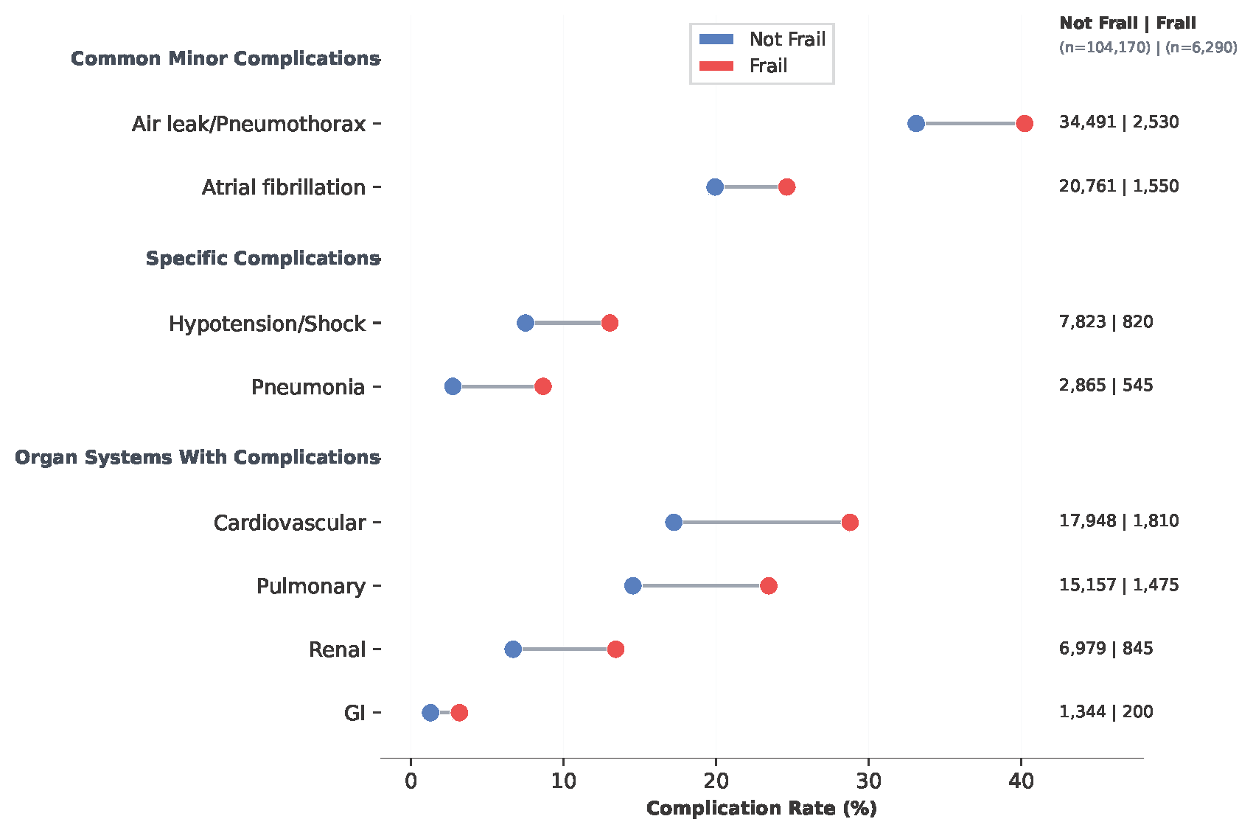

Figure 2: Association of frailty measures with failure-to-rescue after pulmonary lobectomy. Odds ratios and 95% confidence intervals from multivariable logistic regression for (A) HFRS-defined frailty and (B) ACG-defined frailty
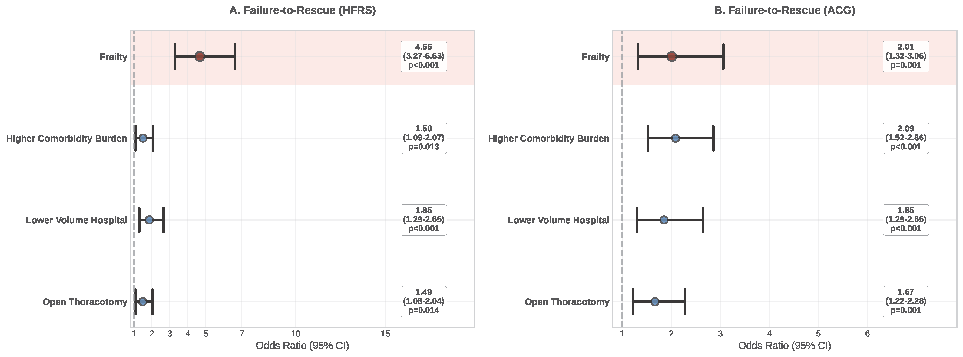

Figure 3: Association of frailty measures with in-hospital mortality after pulmonary lobectomy. Odds ratios and 95% confidence intervals from multivariable logistic regression for (A) HFRS-defined frailty and (B) ACG-defined frailty
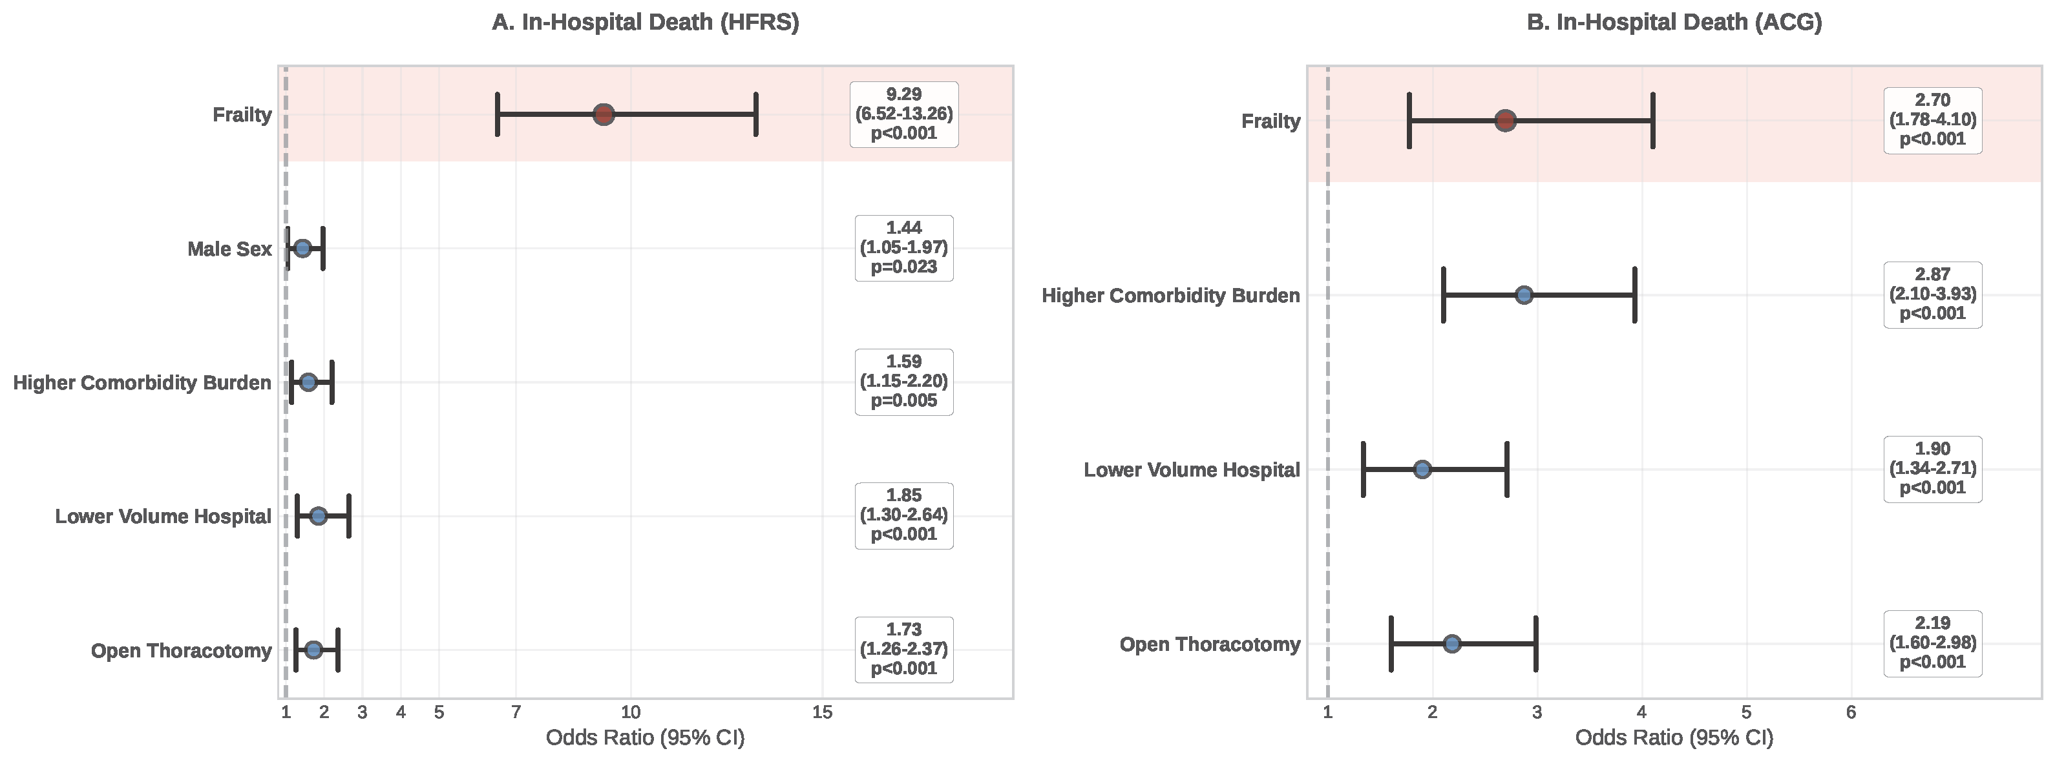

Figure 4: Patient distribution and in-hospital mortality following pulmonary lobectomy by Hospital Frailty Risk Score
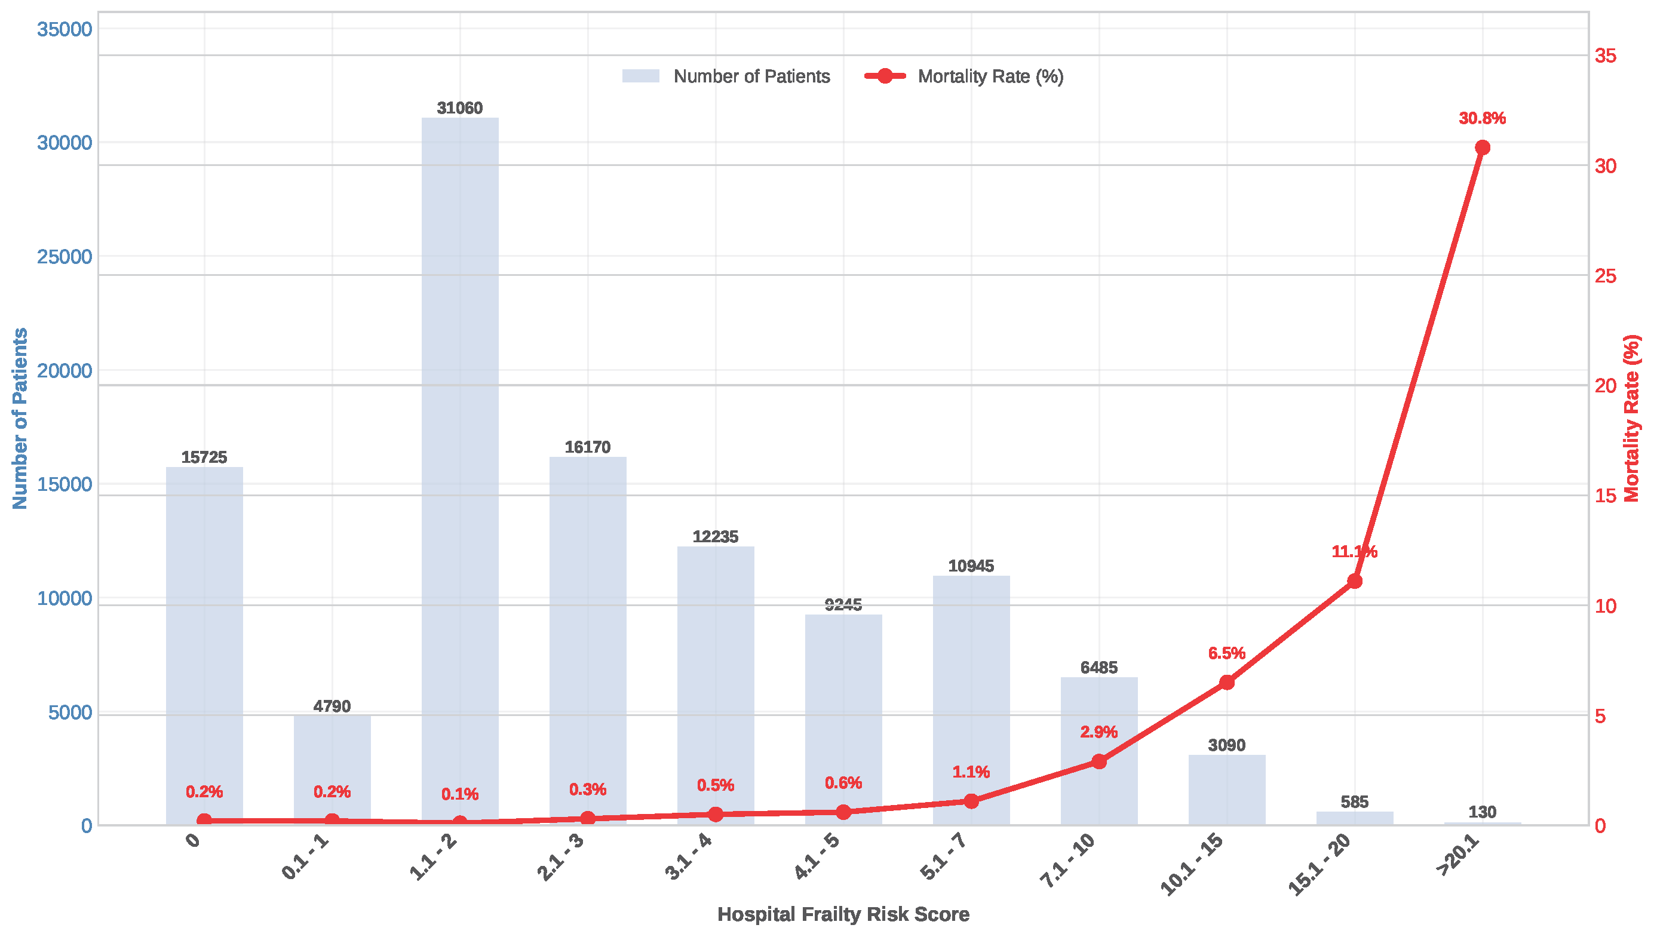

AHRQ HCUP NIS (2016 – 2022)
Hospitalizations associated with pulmonary resection
n= 235,575

Exclusionary patient features
Age <65 years = 88,145
Missing information on sex = 15
Missing vital status at discharge = 35
Lacking lung cancer diagnosis = 46,250

Missing patient characteristics

Age <18 or missing (n=5913)
Missing gender (n=40)
Missing information on death (n= 51)
Patients without primary lung cancer diagnosis (n= 71400)

n= 128,120

Exclusionary procedural features
Non-elective hospitalization or procedure not on day of admission (n=13,020)
Length of stay missing or >14 days (n=4610)

Final cohort
n=110,460

Supplemental figure 1: Study flowchart. A hospitalization record may have >1 exclusionary feature.
AHRQ: Agency for Healthcare Research and Quality; HCUP: Healthcare Cost and Utilization Project; NIS: Nationwide Inpatient Sample

